**Pharma Retailer Reports Other than MIS Reports**

1. **Goodswise Batchwise Stock Ledger :**
2. Select “Goodswise Batchwise Stock Ledger” Menu Path :-Reports-> Pharma Retails Reports--> Stock List and Ledger--> Goodswise Batchwise Stock Ledger.

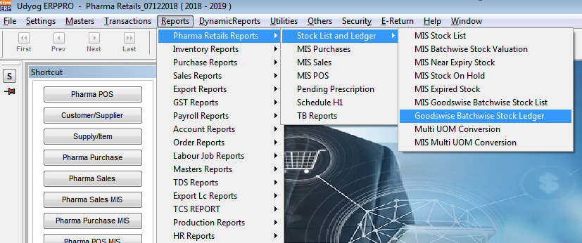

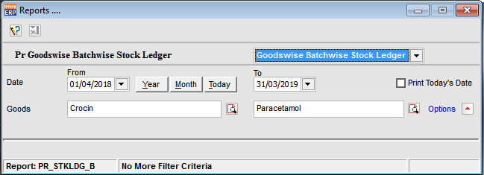

1. In this report, data reflects from those transactions whose settings for Stock Effect is plus or minus in Transaction Settings and other than default Sales, Purchase and Delivery Challan and batch no. is not empty. Data is shown as batchwise.
2. Below is the report :

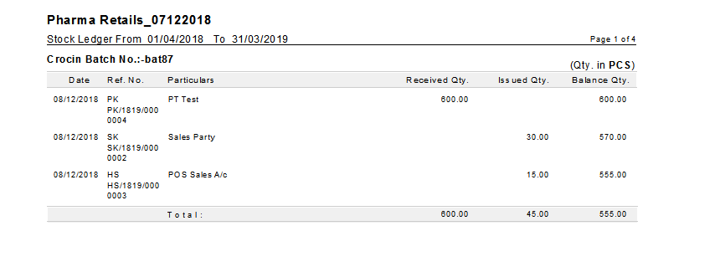

1. **Multi UOM Conversion :**
2. Select “Multi UOM Conversion” Menu Path :-Reports-> Pharma Retails Reports--> Stock List and Ledger--> Multi UOM Conversion.

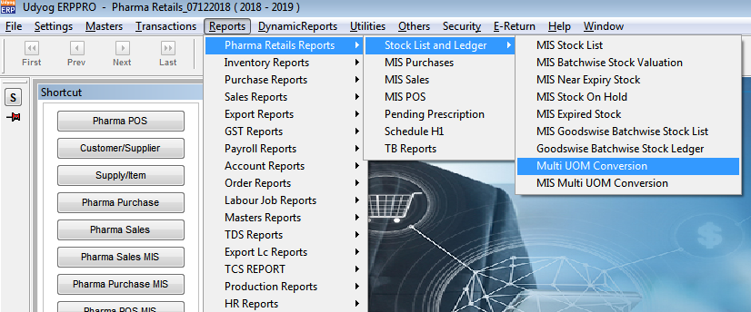

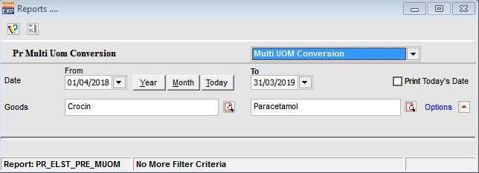

1. In this report, data reflects from those transactions whose settings for Stock Effect is plus or minus in Transaction Settings. Goodswise/UOMwise data is shown.
2. Below is the report :

